WEEBLY Guide

www.weebly.com

Registration

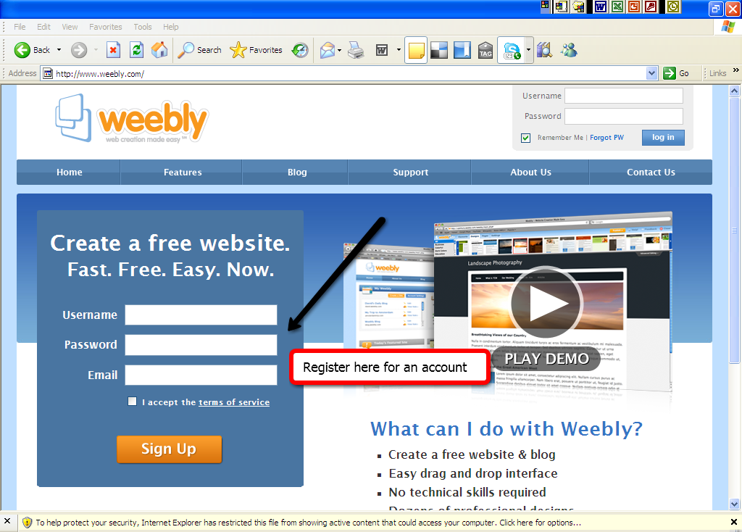

Signing In and Out

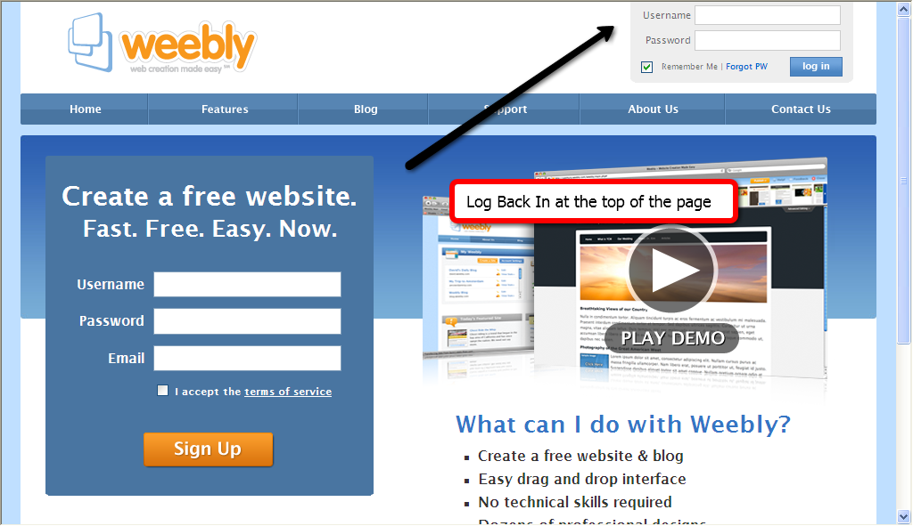

Home Page:

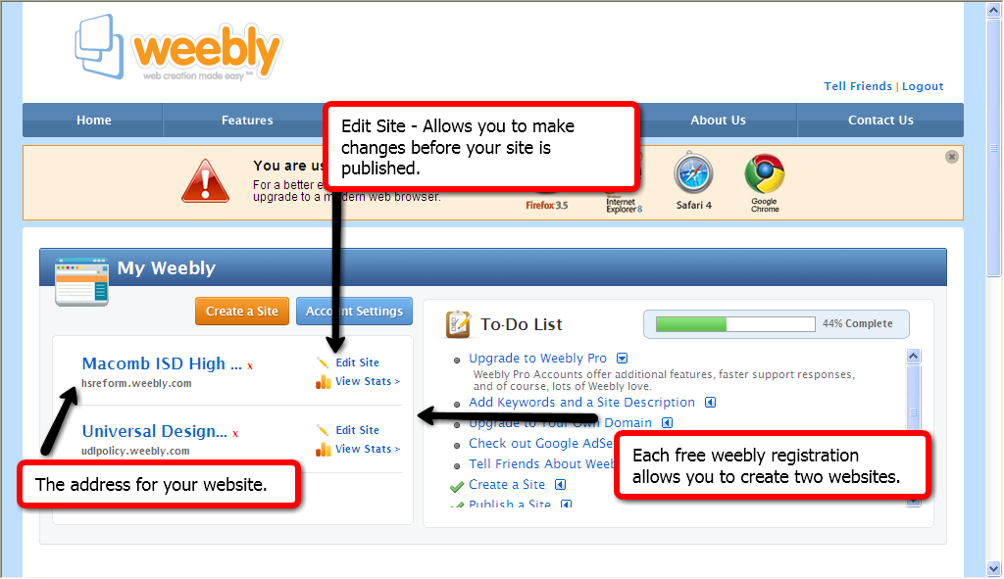

Website Page for Editing

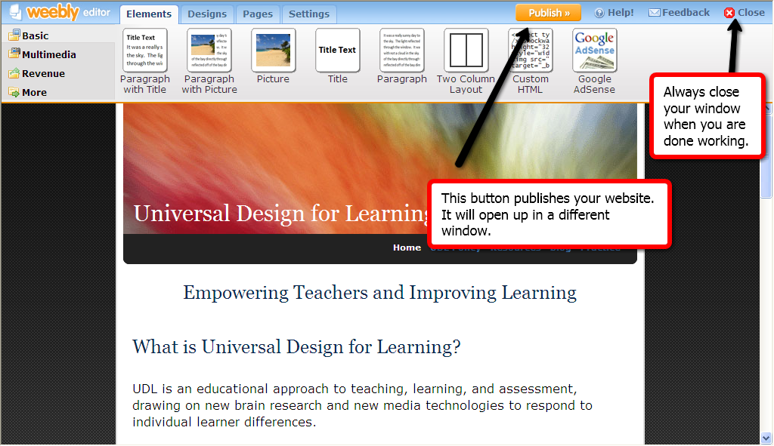

Choosing a Design

The "Design" tab contains a variety of theme/template choices.
Hover your mouse over a design thumbnail to get a preview of the design on your website.
Click the thumbnail to save the design selection for your website.
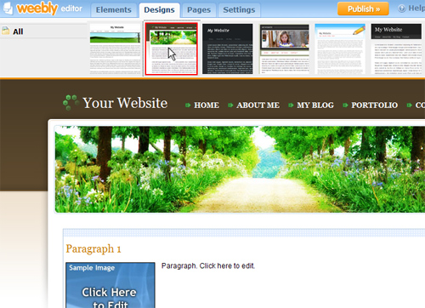

Site Settings
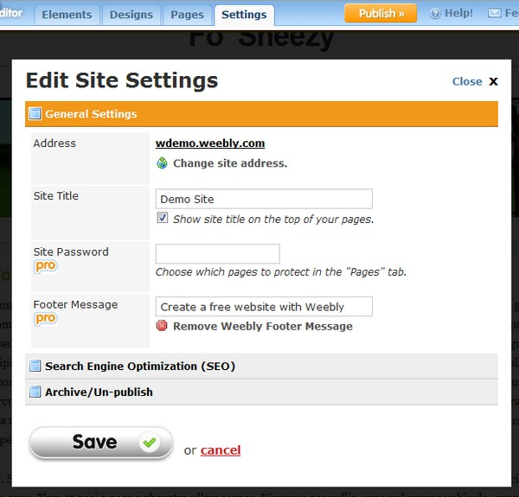
Address:
This area displays your current website addresss. Click on "change site address" in order to change your website address to a different sub-domain of weebly.com, upgrade to your own domain name, or configure and existing domain name with Weebly. For more information, see publishing.
Site Title:
This name will be placed at the top of your website as the site title. To hide the site title from displaying on your pages, uncheck the option and republish your site.

Working With Elements
Elements function as the building blocks of your pages. Paragraphs, Videos, and Maps are examples of element types. These are located at the top of your screen under the “Elements” tab.
To add elements to your page, drag them from the top bar into the content area of your website:
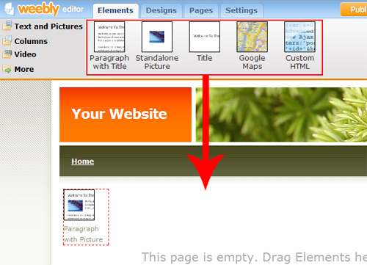
To reorder elements, drag them by the blue bar and place them into a new position:
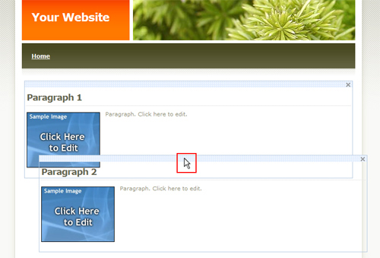
To delete an element, just click on the X in its top right corner:
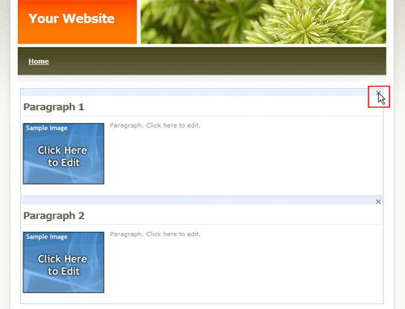

Using the Text Editor
Edit the text within your website by clicking on it to bring up the text editing options above.
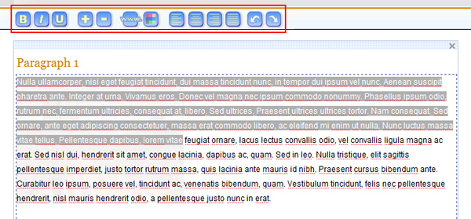Adjust the text color or align your text left/center/right/justified:
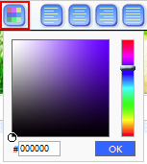
Bold, Italicize, or Underline the text:
Increase or Decrease the font size:
Undo or Redo your changes:

Creating Links

To create a text link
1. Highlight the desired text and click on the link icon in the Element Options toolbar
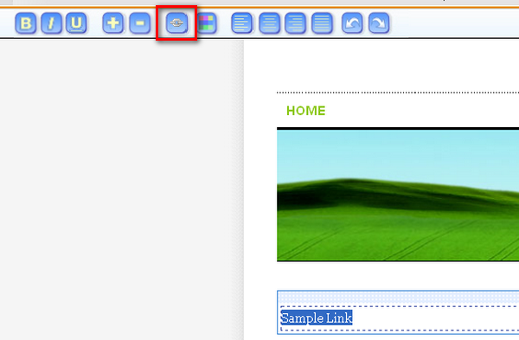

2. Next, you will need to choose which type of link to create. If you wish to link to an external site, you can do so from the "Website" tab pictured below.
NOTE: Links will become active once your site is published.
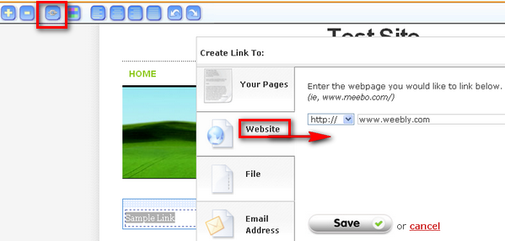

To link a photo
1. Drag the Picture element to your page and click on it
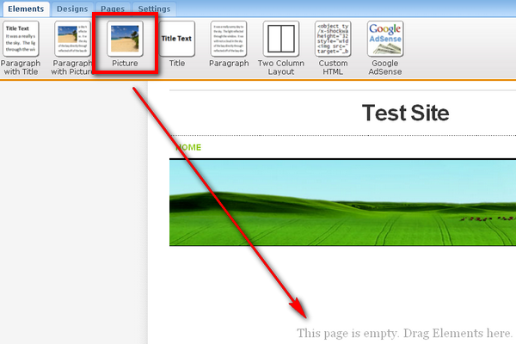

2. An Element Options toolbar will drop down. Click on "Upload new Image" and choose a picture.
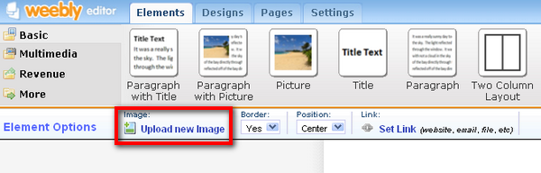

3. Click on the "Set Link" button. A box will pop up that allows you to choose which type of link to create.
NOTE: Links will become active once your site is published.
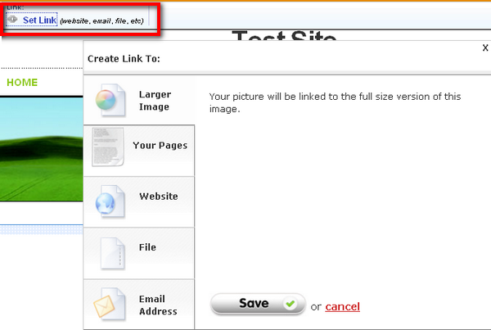

To link a file
1. Create a hidden page in your site under the "Pages" tab
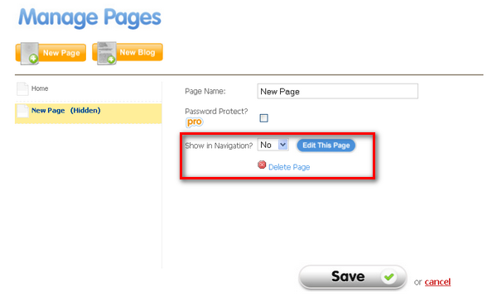

2. Next, upload a file in a normal matter onto this hidden page
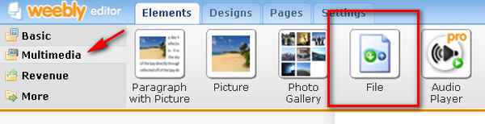

3. In your main page, select the text you want to link and click on the linking icon. Go the file tab, and select the uploaded file from the drop down list.
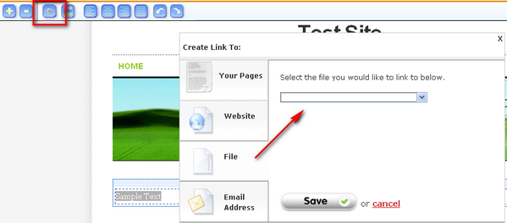

Managing Pages
Manage your pages under the "pages" tab:
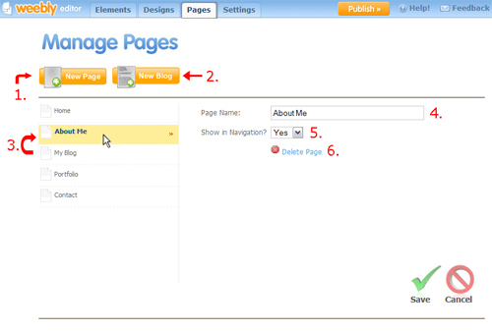
Add a New Page (1) by clicking the "New Page" button.
Add a Blog (2) by clicking the "New Blog" button.
Reorder a Page (3) by dragging the page icon to the left of the page name into a new order.
Bring up the page properties by clicking its respective name in the left column.
Rename a Page (4) by editing the text in the "page name" box.
Hide Pages (5) from appearing in the navigation menu by selecting "no" to "show in navigation". You can link to the hidden pages from visible pages using the text editing/linking tool.
Delete a page (6) by clicking the "delete page" link and confirming.
Save your changes by clicking the green check mark on the bottom right.

Publishing Your Site
To publish your website, you have 3 options:
- A subdomain of weebly.com (free)
- Register a new domain
- Setup a domain already already registered
Choosing a subdomain of weebly.com (for example: yoursite.weebly.com) is completely free and quick way to get online. As you type, Weebly will tell you if your desired subdomain is available.
Registering your own domain name through Weebly (for example: www.yoursite.com) is also very easy. Your website will be visible at the new domain name in minutes without any setup required. If you are upgrading from a subdomain of weebly.com to your own domain, traffic to your old address will automatically be forwarded to the new one.
In addition, we offer you the ability to setup a domain already registered externally on a site such as GoDaddy with your Weebly site. For more instruction on setting this up, see here.
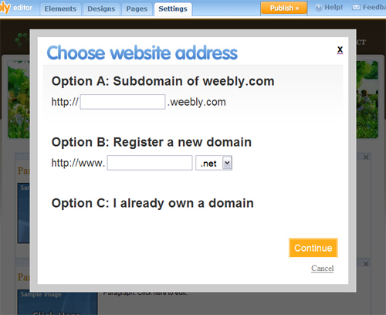

Weebly Support
Table of Contents

For Weebly help go to support at www.weebly.com
A help guide to using Weebly.com
- 1. USING THE WEEBLY EDITOR
  - 1.1. Working with Elements
  - 1.2. Using the Text Editor
  - 1.3. Creating Links
  - 1.4. Managing Pages
  - 1.5. Creating a Blog
  - 1.6. Choosing a Design
  - 1.7. Site Settings
  - 1.8. Publishing Your Site
  - 1.9. Registering a Domain with Weebly
  - 1.10. Uploading a Header Image
  - 1.11. E-Commerce: Setting up Google Checkout
  - 1.12. Using the 2-Column Element
  - 1.13. Using the YouTube Video Element
  - 1.14. Creating Sub-Pages
  - 1.15. How To Upload Files
  - 1.16. Using the Custom HTML Element
  - 1.17. Using the Photo Gallery Element
  - 1.18. Using the Flickr Element
  - 1.19. Using the Contact Form
  - 1.20. Password Protection (Pro)
  - 1.21. Audio Player Element (Pro)
- 2. HOW TO
  - 2.1. Make Money with Google AdSense
  - 2.2. Verify Your Site with Google
  - 2.3. Index Your Site with Search Engines
  - 2.4. Add Google Analytics
  - 2.5. Setup Email with your New Domain
  - 2.6. Add a better contact / RSVP form
  - 2.7. Embed Documents into your Site
  - 2.8. Add Games
  - 2.9. Add PayPal for Simple E-Commerce
  - 2.10. Add a Calendar
  - 2.11. Add a Guestbook
  - 2.12. Configure a Domain Already Registered
  - 2.13. Configure a Domain - GoDaddy
  - 2.14. Configure a Domain - 1&1 Internet
- 3. TROUBLESHOOTING
  - 3.1. Why isn't my domain working?
  - 3.2. I am having trouble logging in, help!
  - 3.3. Why don't my AdSense ads show up?
  - 3.4. Why isn't my website showing my changes?
  - 3.5. Why isn't my site listed in Google?
  - 3.6. I can't click on the upload picture button!
  - 3.7. The Flickr gallery won't show my pictures!
  - 3.8. Why doesn't the blog work when I downloaded my website to zip?
  - 3.9. Why can't I click to edit my text?
  - 3.10. Why is my header image cut off?
  - 3.11. Why is there a white box covering my page in edit mode (LINUX)?
- 4. FREQUENTLY ASKED QUESTIONS
  - 4.1. Is Weebly Free?
  - 4.2. I want to suggest a new feature!
  - 4.3. What's included with Weebly Pro?
  - 4.4. How do you upload a picture?
  - 4.5. Can I add a favicon?
  - 4.6. How do I put elements next to each other?
  - 4.7. How do I change my website URL address?
  - 4.8. Can I make changes after my site is published?
  - 4.9. How do I create hidden / subpages?
  - 4.10. Can I edit my site later?
  - 4.11. Do you have a comment / guestbook element?
  - 4.12. How do I customize the design & background?
  - 4.13. Can I upload a file?
  - 4.14. How do I make a sitemap?
  - 4.15. How do I delete a website?
  - 4.16. How do I delete my account?

